# Installation Skype for Business 2016 Client

Download ISO from blackboard

Mount (Virtual CloneDrive or use your own tools) or burn the ISO to DVD

Depending on your OS go to the corresponding folder (x*86* for 32-bit machines, x*64* for 64-bit machines)

**Note:** If you have installed the 32-bit Microsoft Office 2010/2013/2016 suite, use the 32-bit version of Skype for Business 2016

Run (Mounted Drive): ***Setup.exe***

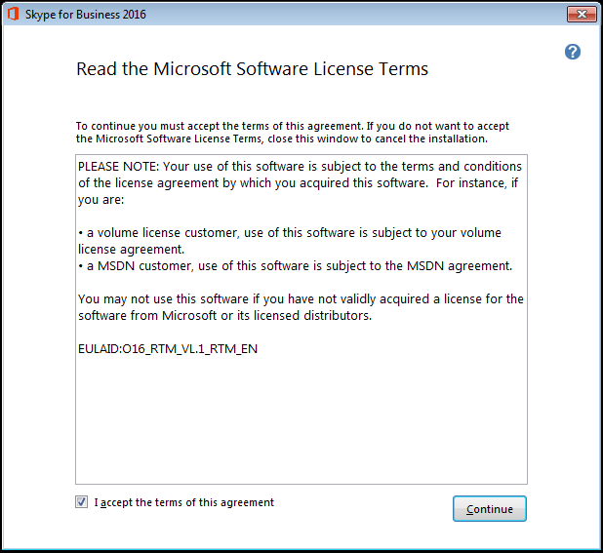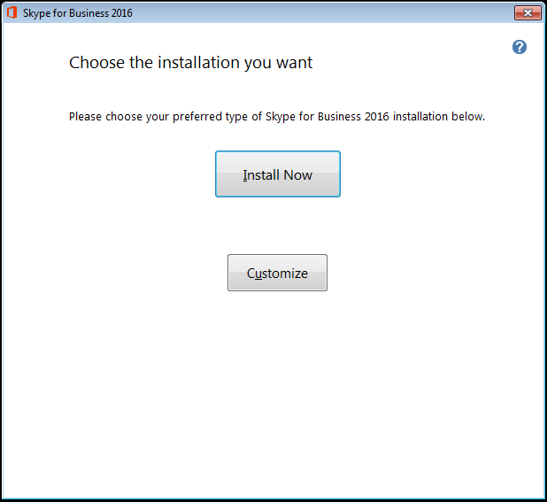

**Select "I accept the terms of this agreement" and click on "Continue"**

**Click on "Install Now "**

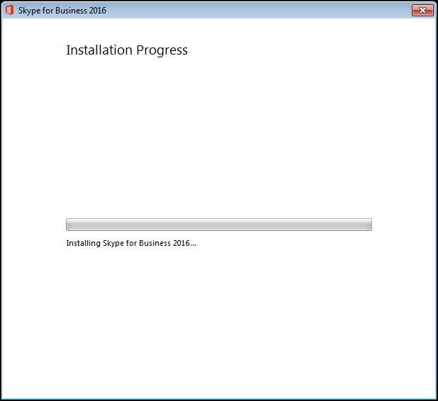 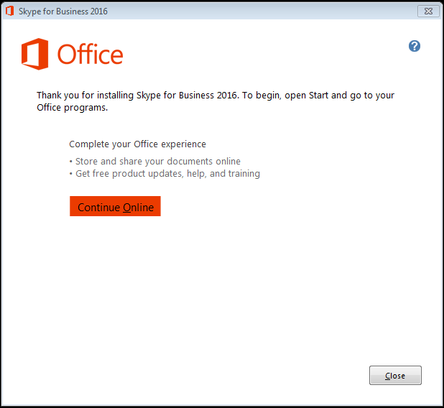

**Click on "Close"**

# Running Skype for Business 2016 Client for the first time.



**Open** **located in the Windows Start Menu.**

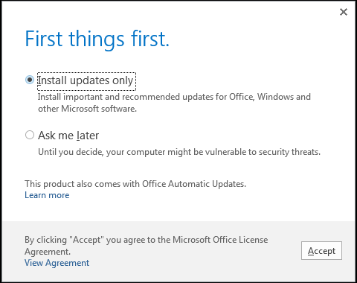

**Depending on your Preference,   
Select "Install updates only" or "Ask me Later" and click on "Accept"**

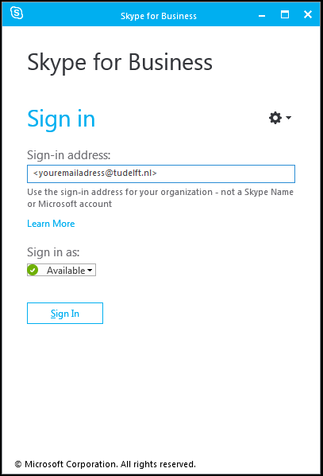

**Fill-in your (TUD) email address, and select Sign In...**

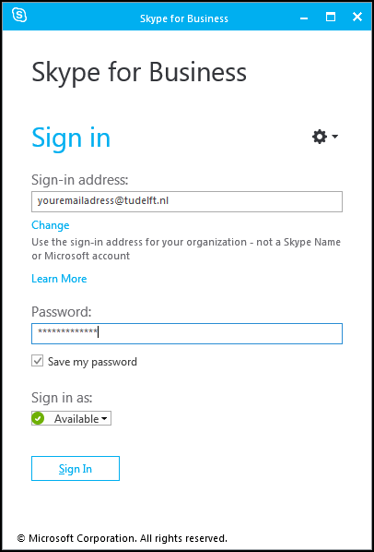

**Fill-in your Password : <password> , Select Sign In.**



**Click on "OK"**

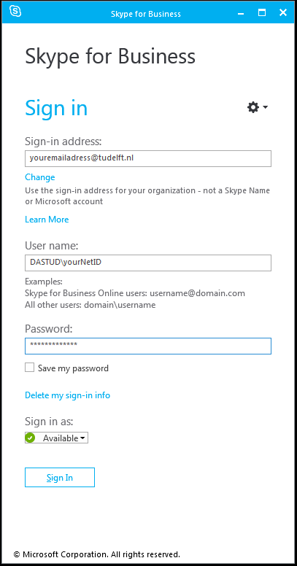

**Fill-in your username: *DASTUD\<Your NetID>* and Password : *<password>* , Select Sign In**

**Run windows update after installation to get the latest updates for Skype for Business 2016.**